|  |
| --- |
| **ASIA PACIFIC COLLEGE**  School of Computer Science and Information  Technology |
| JMGTCC Booking & Reservation System |
| User Manual |
|  |
| **Arianne Bianca F. Papna**  **Erika C. Hidalgo**  **Roxanne Therese A. Luangco**  **IT 111** |
| **A.Y. 2014 - 2015** |

**Mr. Jose Eugenio Quesada**

Professor

Table of Contents

Introduction………………………………………………………………………………………..2

User Groups……………………………………………………………………………………….2

Basic Buttons………………………………………………………………………...……………2

System Modules 2

Maintaining the System…………………………………………………………...……………3

Visa Assistance Appointment Scheduler 3

Create a new Appointment 3

Updated an Existing Appointment 3

Cancel Appointment 3

Travel & Tour Arrangement 3

Customer Service 3



# Introduction

Journeys & More Global Tours and Consultancy Co. (JMGTCC) Travel Arrangement and Appointment System is an application that enables client’s of JMGTCC to create their own travel detail arrangement and for the application guests to schedule an appointment for visa assistance instead of relying on the travel agents of the agency to cater the basic needs of their clients.

# User Groups

**Admin/Encoder** is the person in charge of maintaining the system, managing all the travel arrangement records and appointment records and the one who has complete access with both the backend and frontend perspective of the system. The admin is the one who can update and add record to the system for all the maintenance modules or the dynamic values that clients or frontend users select from.

**Registered Clients** are the users who has full on access on the frontend side of the system. They create travel arrangements and visa appointment.

**Guests** are users who haven’t signed up on the site, though they can view the frontend of the system. The only feature that the guests can access is visa appointment and customer support.

# 

# Basic Buttons

All icons listed below are basic buttons that can usually found in grid tables of the system.

|  |  |  |
| --- | --- | --- |
| **Icon** | **Button Name** | **Description** |
|  | View Button | This button redirects the user to a page wherein users can view the details of a single record. |
|  | Edit Button | This button allows users to edit or modify a specific record. |
|  | Delete Button | This button is used to delete records and wipe out the record in the system. |

# System Modules

The System modules are the following:

* **Maintenance Modules**

The maintenance module contains 7 sub modules namely Airlines, Food Deals, Freebies, Time, Tour Type, Transport Service and Personnel. The modules under this are controllable modules that the admin can modify and in turn affects the frontend forms wherein clients select from.

* **Appointment Scheduler (Visa Assistance)**

In the customer module of the system, clients can have access to the system in case they want to schedule a Visa Assistance Appointment with the General Manager.  They will input their name, email address, phone number, appointment time and day and optional remarks or message.

* **Travel & Tour Arrangement**

The Client inputs necessary details about the travel packages he wants to avail. He can choose from the list of travel packages offered by the agency or request for a new travel package-combination or arrangement.

* **Customer Service / Technical Support**

This is an online chat support feature that enables the clients of JMGTCC to communicate with the company IT Support Team through the application.  The client can send a direct / instant message about technical concerns to the IT Support Team.

Maintaining the System

To make sure that the system stays up to date and the information in the frontend are updated, the maintenance modules should be constantly updated by the admin. The seven maintenance modules can be found in the backend/admin side of the system and located at the left side of the home page.

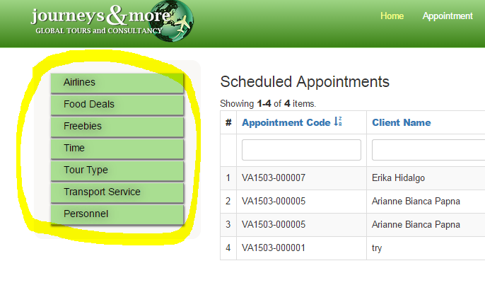

To start updating simply click on one of the buttons and it will redirect to the index page of the chosen sub module. All sub-modules under the maintenance modules has the same process the only difference the values and the purpose of each and on what form they are accessible in the frontend.

Here is a step by step example for the Food Deals of how to manage one of the sub-modules:

1. Familiarizing with the modules index page

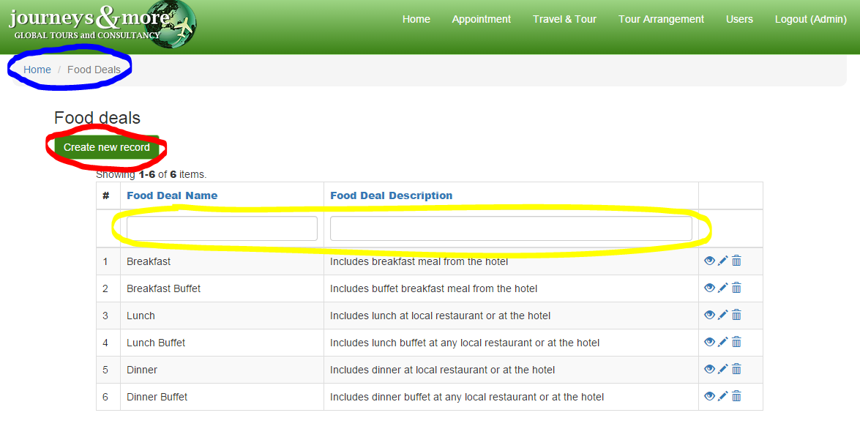

The index page of every module display the same as what is in the diagram. The index page basically contains the grid table containing the records and the basic buttons which are described in the *Basic Buttons* section of this manual. The following are some of the main parts of the page to remember.

1. The **breadcrumb** is illustrated in the diagram above in a **blue mark**. It works like a root directory of a system file and it determines whether on what part of the system are you in
2. The **create new button** is illustrated in the diagram above in **red mark.** This is used to add or create a new record for the module that you are in.
3. The **search box** is illustrated above in the diagram in **yellow mark**. This text boxes are used as an engine to search for any existing records with a use of a search key or term/word that the user wants to look for.
4. Creating a new record

After clicking create new button in the previous step, the system will redirect to a form wherein the new record details will be validated. After the forms has been filled up simply click the create button located at the bottom of the form.

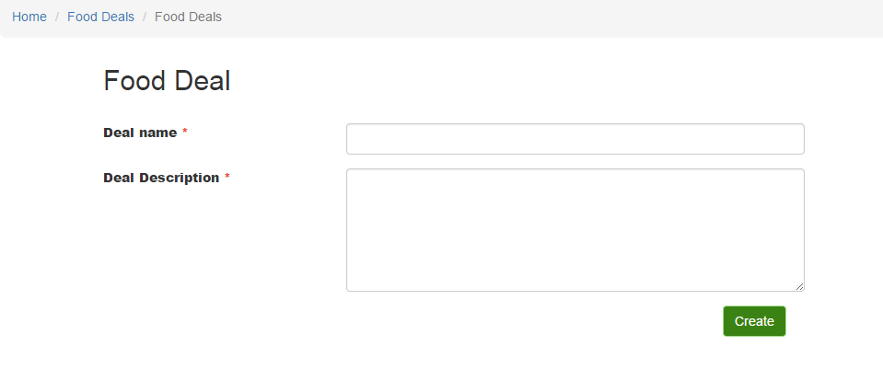

When a red asterisk is present beside the form label, this means that the form field or text box cannot be blank.

1. When a record is successfully created, the system will redirect to a page similar to this:

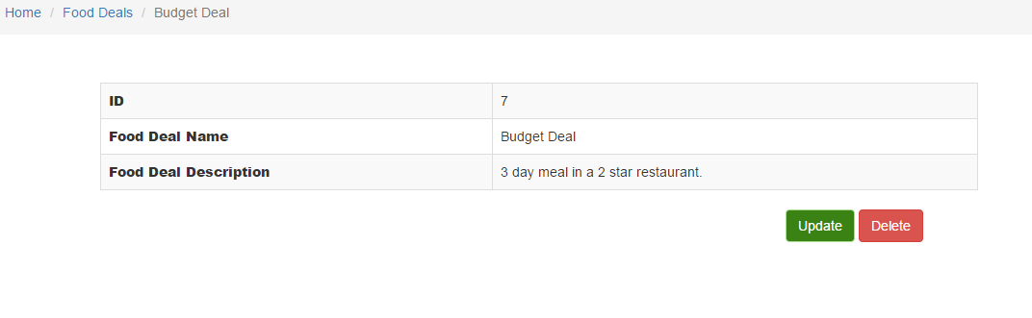

This record can also be seen in the grid table in the index page. As what is illustrated above, there are two buttons located at the bottom of the created record table. To update, simply click the update button.

To delete, click the red button labeled delete and the user will be asked for a confirmation whether they really want to delete the record. When “OK” is clicked the record will be deleted and if cancel is clicked the process of deletion will also be cancelled.

1. To update the record, change the values in the form and click update.

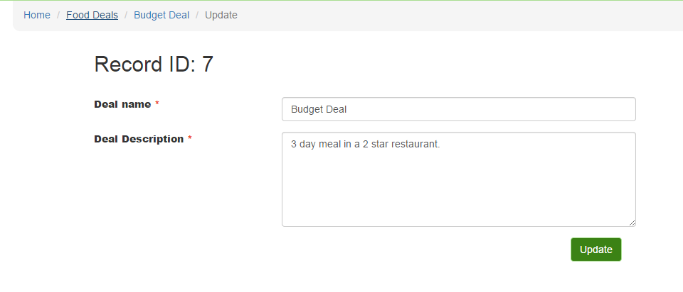

All processes can be confirmed if the changes made are seen in the grid table of records of the index page.

Visa Assistance Appointment Scheduler

### Create a new Appointment

### Update an Existing Appointment

### Confirmation of Appointment (Backend)

## 

## Travel & Tour Arrangement

### Create Travel & Tour Arrangement

### Update an Existing Travel & Tour Arrangement

### Viewing of Arrangement Made (Backend)

## Customer Service